Math 10

Lesson 2-4 Factoring special polynomials

Lesson Objectives:
a) Although factoring by decomposition will always work, some trinomials are easier to factor than others.

Special polynomials

When a = 1
Although the decomposition method works to factor many polynomials, there are some polynomials that are easier to work with. For example, many of you have probably noticed that when a = 1 for trinomials of the form ax² + bx + c, the two factors of c that add up to b can be written immediately as two binomials. For example, consider x² – 7x + 12. The two factors of 12 that add up to –7 are –3 and –4. Therefore we can write the factors as:
x² – 7x + 12 = (x – 3)(x – 4)

Question 1
If possible, factor each trinomial.
a) x² + 2x – 8 b) a² + 7a – 18 c) –30 + 7m + m²

Difference of Squares
Consider something like x² – 25. The expression is a binomial and the first term is a perfect square, the last term is a perfect square and the operation between the terms is subtraction – hence a difference of squares. To factor it we write the terms “in squared form.” The factors are the positive and negative values of the second term.
x² – 25 = x² – 5²
=(x – 5)(x + 5)
Note, it must be a difference of squares, not an addition of squares.

Question 2
If possible, factor each binomial.
a) x² – 9 b) 16a² – 25c² c) 7g³h² – 28g⁵

Question 3
Show why it is not possible to factor m² + 16.

Perfect Square Trinomials
A perfect square trinomial is of the form (ax)² + 2abx + b² or (ax) ² – 2abx + b². The first term is a perfect square, the last term is a perfect square, and the middle term is twice the product of the square root of the first term and the square root of the last term. For example, consider
x² + 16x + 64
Note that x² is a perfect square, 64 is a perfect square (8²), and 16 = 8 + 8.
x² + 16x + 64
= x² + 8x + 8x + 64
= x(x + 8) + 8(x + 8)
= (x + 8)(x + 8)

Question 4
If possible, factor each trinomial.
a) x² +6x + 9 b) 2a² – 44a + 242 c) h² – 12h – 36

Assignment
1. Identify the factors of the polynomial shown by each algebra tile model.
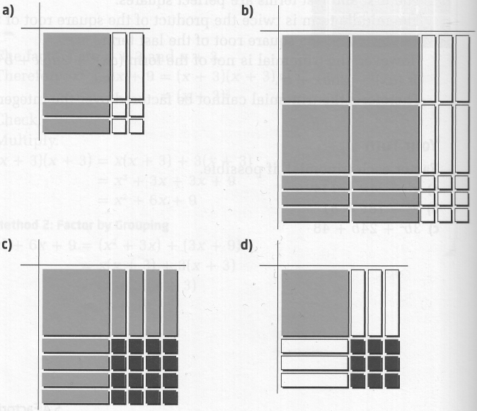

2. Determine each product.
a) (x – 8)(x + 8) b) (2x + 5)(2x – 5)
c) (3a – 2b)(3a + 2b) d) 3(t – 5)(t + 5)

3. What is each product?
a) (x + 3) ² b) (3b – 5a) ²
c) (2h + 3) ² d) 5(x – 2y) ²

4. Factor each binomial, if possible.
a) x² – 16 b) b² – 121
c) w² + 169 d) 9a² – 16b²
e) 36c² – 49d² f) h² + 36f²
g) 121a² – 124b² h) 100 – 9t²

5. Factor each trinomial, if possible.
a) x² + 12x + 36 b) x² + 10x +25
c) a² – 24a – 144 d) m² – 26m + 169
e) 16k² – 8k + 1 f) 49 – 14m + m²
g) 81u² + 34u + 4 h) 36a² + 84a + 49

6. Factor completely.
a) 5t² – 100 b) 10x³y – 90xy
c) 4x² – 48x + 36 d) 18x³ + 24x² + 8x
e) x⁴–16 f) x⁴ – 18x² + 81

7. Each of the following polynomials cannot be factored over the integers. Why not?
a) 25a² – 16b b) x² – 7x – 12
c) 4r² – 12r – 9 d) 49t² + 100

8. Many number tricks can be explained using factoring. Use a² – b² = (a – b)(a + b) to make the following calculations possible using mental math.
a) 19² – 9² b) 28² – 18²
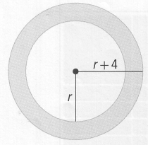
c) 35² – 25² d) 5² – 25²

9. The diagram shows two concentric circles with radii r and r + 4.
a) Write an expression for the area of the shaded region.
b) Factor this expression completely.
c) If r = 6 cm, calculate the area of the shaded region. Give your answer to the nearest tenth of a square centimetre.

10. State whether the following equations are sometimes, always, or never true. Explain your reasoning.
a) a² – 2ab – b² = (a–b)² b ≠ 0
b) a² + b² = (a + b)(a + b)
c) a² – b² = a² – 2ab + b²
d) (a + b) ² = a² + 2ab + b²

11. Rahim and Kate are factoring 16x² + 4y². Who is correct? Explain your reasoning.

Rahim
16x² + 4y² = 4(4x² + y²)

Kate
16x² + 4y² = 4(4x² + y²)
= 4(2x – y)(2x + y)

